Game Design Document

Fill up the following document

1. Write the title of your project.

Save The Princess!!!

1. What is the goal of the game?

The goal is to save the princess from the evil ogres and dragons.

1. Write a brief story of your game.

The princess was kidnapped by an evil dragon and his ogre minions. The knight is hired to rescue her and bring her back to her kingdom.

1. Which are the playing characters of this game?

* Playing characters are the ones who respond to the user based on the input from the user.
* Cars, monkeys, dinos, wizards, etc., are the playing characters in the game.

|  |  |  |
| --- | --- | --- |
| Number | Character Name | What can this character do? |
| 1 | Knight | He can jump up and down as well as right and left. He kills the ogres and dragons |
| 2 | Ogres | Are summoned from all different places, and try to kill the knight |
| 3 | Dragon | Flies around the castle, and tries to kill the knight |
| 4 |  |  |
| 5 |  |  |
| 6 |  |  |
| 7 |  |  |
| 8 |  |  |

1. Which are the Non-Playing Characters of this game?

* Non-Playing characters are the ones that don't have an action or behavior when the user interacts with the game.
* Hurdles, stones, bananas, coins, etc., are non-playing characters in the game.

|  |  |  |
| --- | --- | --- |
| Number | Character Name | What can this character do? |
| 1 | Princess | Saving the princess is the goal of the game. |
| 2 |  |  |
| 3 |  |  |
| 4 |  |  |
| 5 |  |  |
| 6 |  |  |
| 7 |  |  |
| 8 |  |  |

Draw your imagination of this game. What does this game look like?

* Draw the game either on your computer or on paper.
* Add images of the game scenes to show each of the playing and non-playing characters at least once.

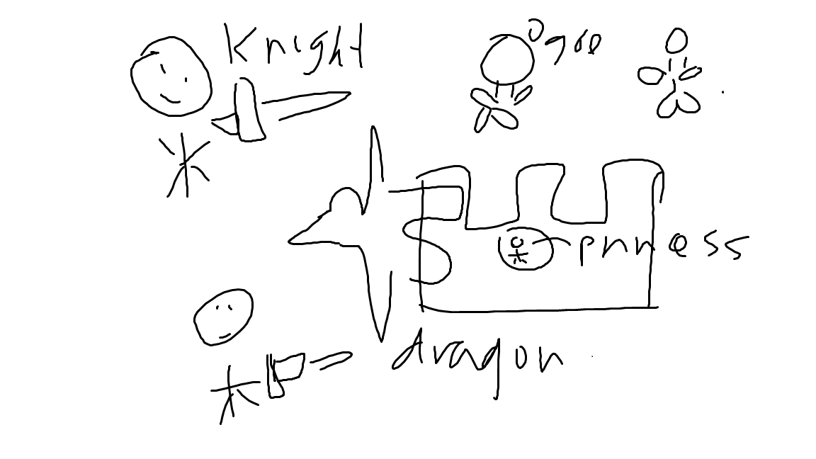

How do you plan to make your game engaging?

I plan to make the game engaging by adding multiple different stages of the game. First you have to go through many ogres and then you have to defeat the dragon. You have health packages but can die from multiple interactions with the ogres and dragons.